This is the SRS for our ESE Project 2017. This document should show how our project is designed and what is done by it. SRS is a standard for the specification of software.

Software Requirements Specification

Cantor-Russel-Project Team 1, ESE 2017 12.12.2017

Damaris Meier, Jasmin Sert, Julien Del Don, Corina Masanti, Angela Keller

Index

Introduction 4

Purpose 4

Stakeholders 5

Definitions 5

System overview 5

References 5

Overall description 6

UML diagrams 6

Use cases 8

Use Case 1 9

Use Case 2 9

Use Case 3 10

Use Case 4 10

Use Case 5 11

Use Case 6 11

Use Case 7 12

Use Case 8 12

Use Case 9 13

Use Case 10 13

Use Case 11 13

Use Case 12 14

Use Case 13 14

Use Case 14 15

Use Case 15 15

Actor characteristics 16

Logisticians: 16

Drivers: 16

Customers: 16

EPK 17

Specific requirements 18

Functional requirements 18

Login Page 18

User Class 1 – The Logistician 18

User Class 2 – The Driver 21

Walk-through-diagram driver 23

Walk-through-diagram logistician 23

Non-functional requirements (external, performance, etc.) 24

Desktop and mobile version 24

Browsers 24

Performance 24

Security 24

Usability 24

Documentation 24

Design constraints 24

Colors 24

Contrast 24

Buttons 25

Personalization 25

Consistency 25

Toolbar 25

Software System attributes 25

Framework 25

Program structure 25

Software requirements specification – Team 01

# Introduction

## Purpose

The goal of this software is to provide an application to simplify the process from ordering to delivery. In the current situation, everything is done by hand from each employee in the process line, leading to an excessive amount of paper work. With an automated system the company wants to improve the efficiency of their logistics.

This Software Requirements Specification document serves as a guideline for the project and gives a detailed overview of the functionalities of the software. Its aim is to capture the needs of the company *RCP* and establish a common understanding of the functional and non-functional requirements of the project.

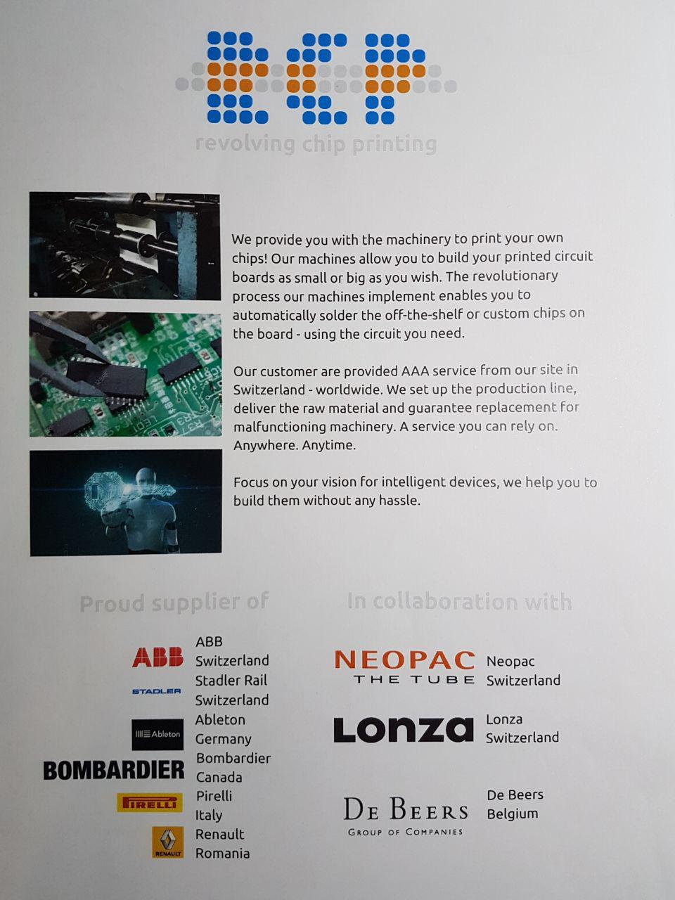

## Stakeholders

The stakeholders are Manuel Leuenberger of the company *RCP* and its employees including the logisticians and drivers.

## Definitions

**Logistician**: employee who handles incoming orders, prepares tours and assigns a driver for each tour.

**Driver**: carries out the tours, which are assigned to him, and delivers the products to the customer.

**User:** can be either a logistician or a driver

**Customer**: company to which the products are delivered to and which is able to accept or reject the delivery.

**Tour**: is a composition of different orders assembled by a logistician.

**Accepted delivery**: the order is successfully delivery and marked as accepted by the driver.

**Rejected delivery:** the order could not be successfully delivery due to a mistake in the delivery or the unavailability of the customer. It is then put back into the unassigned orders.

## System overview

The system should:

* Save the logisticians in the database, they have the access to add, change and look up things
* Save the drivers in the database, they can just look up things and add the state of the order
* Save the customers with their addresses in the database
* Save the orders from the client in a database
* Prepare tours with the different addresses of the clients
* Show the tours for the logisticians on a mobile device
* Let the drivers access the orders for changing the state of the order (delivered, rejected, not there)
* Let the logisticians choose the truck for the driver
* Show the route for the driver on a map (google maps api)

## References

* *IEEE Guide to Software Requirements Specification*. ANSI/IEEE Std 830-1984. IEEE Press, Piscataway/New Jersey 1984.
* Colin Hood, Susanne Mühlbauer, Chris Rupp, Gerhard Versteegen (Hrsg.): *iX-Studie Anforderungsmanagement*. Methoden und Techniken, Einführungsszenarien und Werkzeuge im Vergleich. 2. Auflage. Heise, Hannover April 2007
* <http://www.sws.bfh.ch/studium/cas/swe-fs13/Projekt/SRS/SRS_Floorball_Eventer.pdf>
* <https://www.johner-institut.de/blog/tag/systemanforderungen-system-requirements-specification/>
* Vorlesungsfolien ESE 2017
* <http://www.cse.chalmers.se/~feldt/courses/reqeng/examples/srs_example_2010_group2.pdf>

# Overall description

## UML diagrams





## Use cases

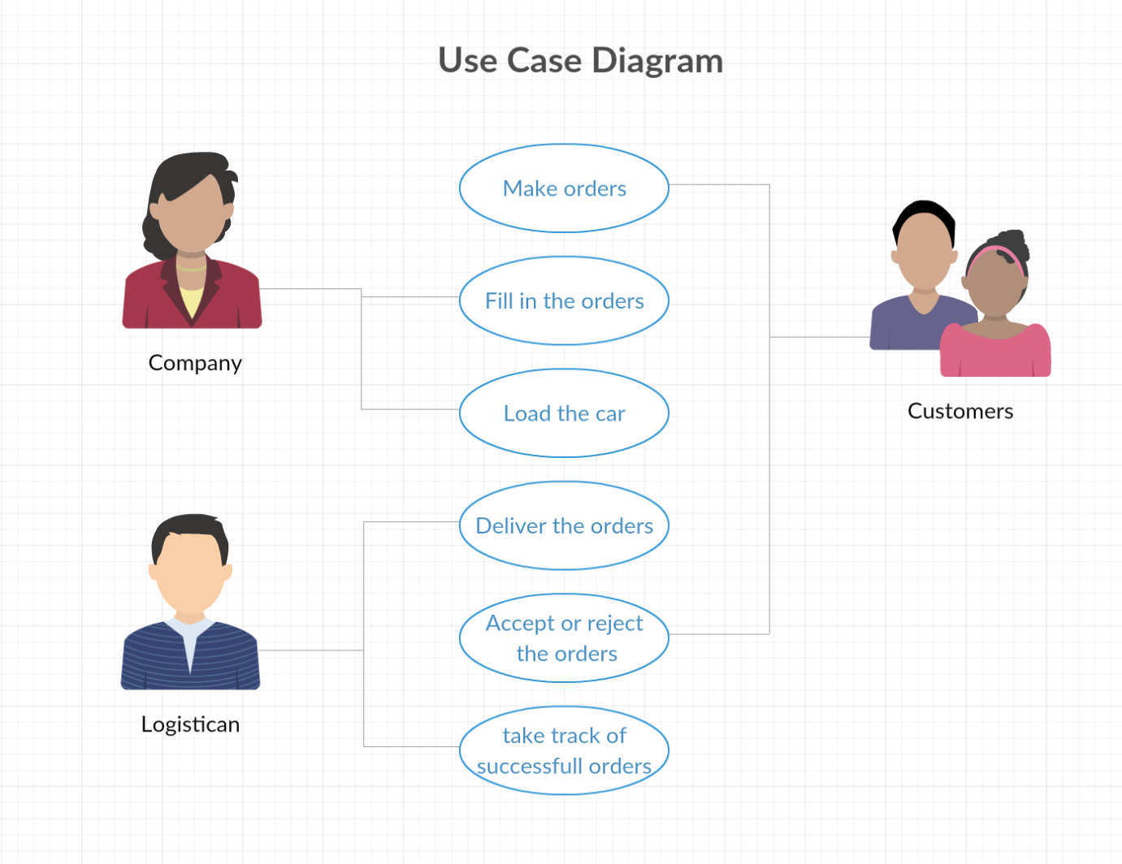

### Use Case 1

**Name:** Log into the system.

**Description:** A driver or logistician, which is already registered visits the website and logs in with his credentials.

**Preconditions:** User has access to the Internet, has an account on the website, knows his e-mail address and password

**Event Flow:** 1. User types in e-mail address

2. User types in password

3. User clicks login button.

4. System checks whether the credentials are correct

5. User is led to the driver or logistician homepage, depending on which he has access to. In case either the e-mail address or the password is incorrect, the user is requested to verify.

**Alternate Scenario:** 1. User types in e-mail address

2. User types in password

3. User clicks login button.

4. System detects invalid input of either the e-mail or password

5. User is requested to verify and type in e-mail and password again

### Use Case 2

**Name:** Log out of the system.

**Description:** A driver or logistician, who is logged in, logs out of the system.

**Precondition:** User has access to the Internet, has an account on the website, knows his e-mail address and password, is logged in

**Event Flow:** 1. User sees Log out button on the top right of the website

2. User clicks Log out button and is taken back to the Login page

__________________________________________________________________________________

### Use Case 3

**Name:** Overview orders

**Description:** A logistician wants to have an overview of all the unassigned and accepted orders.

**Precondition:** Logistician has access to the Internet, is logged in. At least one order exists.

**Event Flow:** 1. Logistician sees ‘Aufträge’ button on the homepage

2. Logistician clicks ‘Aufträge’ button and is taken to the list of orders

### Use Case 4

**Name:** Make a new order with a new customer

**Description:** A logistician wants to create a new order with a new customer in the system

**Precondition:** Logistician has access to the Internet, is logged in.

**Event Flow:** 1. Logistician sees ‘Neuer Auftrag erstellen’ button on the homepage

2. Logistician clicks ‘Neuer Auftrag erstellen’ button

3. Logistician clicks ‘Neuer Kunde erstellen’ button

4. Logistician fills in the form with the details of the new customer

5. Logistician clicks ‘Kunde speichern’ button and sees list of the details of the created customer

6. Logistician clicks ‘Diesem Kunden einen Auftrag zuordnen’ button

7. Logistician clicks on drop down list and chooses product and types in the amount of products

8. Logistician clicks ‘Bestellung Speichern’ button

**Postcondition:** The order is added to the database.

### Use Case 5

**Name:** Make a new order with an existing customer

**Description:** A logistician wants to create a new order with an existing customer in the system

**Precondition:** Logistician has access to the Internet, is logged in. At least one customer exists.

**Event Flow:** 1. Logistician sees ‘Neuer Auftrag erstellen’ button on the homepage

2. Logistician clicks ‘Neuer Auftrag erstellen’ button

3. Logistician clicks ‘Suche nach Kunden im System’ button

4. Logistician sees list of customer and selects the customer by clicking the ‘Weiter’ button next to the customer

5. Logistician clicks on drop down list and chooses product and types in the amount of products

6. Logistician clicks ‘Bestellung Speichern’ button

**Postcondition:** The order is added to the database.

### Use Case 6

**Name:** Delete an order

**Description:** A logistician wants to delete an existing order.

**Precondition:** At least one order exists.

**Event Flow:** 1. Logistician sees ‘Auftrag löschen’ button next to the order on the page showJobs

2. Logistician clicks ‘Auftrag löschen’ button

3. Logistician clicks ‘Auftrag definitiv löschen!’ button

4. Logistician sees confirmation that order is deleted

**Postcondition:** The order is deleted from the database.

__________________________________________________________________________________

### Use Case 7

**Name:** Create a new tour

**Description:** A logistician wants to create a new tour.

**Precondition:** User has access to the Internet, is logged in. There is at least one existing order and available vehicle and trailer.

**Event Flow:** 1. Logistician clicks ‘Touren’ button on homepage

2. Logistician clicks ‘Neue Tour erstellen’ on the bottom of the page

3. Logistician sees the new tour ID and clicks ‘Los!’

4. Logistician selects the desired driver for the tour by clicking ‘Weiter’

5. Logistician chooses the vehicle by clicking ‘Weiter’ next to it

6. Logistician chooses the trailer by clicking ‘Weiter’ next to it

7. Logistician adds orders to the tour by clicking the ‘+’ button

**Alternate Scenario:** 1. Logistician wants to add an order to the tour

2. Logistician sees notification that there isn’t enough space for the desired order

**Postcondition:** Tour is saved in the database.

### Use Case 8

**Name:** Edit tour

**Description:** A logistician wants to edit an existing tour.

**Precondition:** User has access to the Internet, is logged in. There is at least one existing tour.

**Event Flow:** 1. Logistician clicks on ‘Touren’ on the homepage.

2. Logistician clicks ‘Bearbeiten’ button next to the tour

3. Logistician can add orders to the tour by clicking ‘+’ button, or remove orders from the tour by clicking ‘-‘ button

**Alternate Scenario:** 1. Logistician wants to add an order to the tour

2. Logistician sees notification that there isn’t enough space for the desired order

**Postcondition:** Tour is adjusted in the database.

__________________________________________________________________________________

### Use Case 9

**Name:** Delete tour

**Description:** A logistician wants to delete an existing tour.

**Precondition:** User has access to the Internet, is logged in. There is at least one existing tour.

**Event Flow:** 1. Logistician clicks on ‘Touren’ on the homepage.

2. Logistician clicks ‘Bearbeiten’ button next to the tour

3. Logistician clicks ‘Tour löschen’ next to the tour

4. Logistician is asked to confirm and clicks ‘Tour definitiv löschen’

5. Logistician sees confirmation that tour is deleted

**Postcondition:** Tour is deleted from the database

### Use Case 10

**Name:** Show all users

**Description:** Logistician wants to have an overview over all logisticians and drivers.

**Precondition:** User has access to the Internet, is logged in. There is at least one existing user.

**Event Flow:** 1. Logistician clicks ‘Alle User’ on homepage

### Use Case 11

**Name:** Delete user

**Description:** Logistician wants to delete either another logistician or a driver

**Precondition:** User has access to the Internet, is logged in. There is at least one existing user.

**Event Flow:** 1. Logistician clicks ‘Alle User’ on homepage

2. Logistician clicks ‘User löschen’ next to the user the wants to delete

3. Logistician is asked to confirm and clicks ‘User definitiv löschen!’

4. Logistician sees confirmation that tour is deleted

**Postcondition:** User is deleted from the database.

__________________________________________________________________________________

### Use Case 12

**Name:** Create new user

**Description:** Logistician wants to create a new logistician or driver

**Precondition:** User has access to the Internet, is logged in.

**Event Flow:** 1. Logistician clicks on ‘Alle User’ button on homepage

2. Logistician clicks on ‘Neuer User erstellen’ at the bottom of the page

3. Logistician selects the role and fills in the form with the details of the new user

4. Logistician clicks ‘User speichern’

**Postcondition:** New user is saved in the database

### Use Case 13

**Name:** Show tours

**Description:** Driver wants to have an overview over his upcoming tours.

**Precondition:** User has access to the Internet, is logged in. There exists at least one tour that has been assigned to this driver.

**Event Flow:** 1. Driver clicks on ‘Touren anzeigen’ on the homepage

2. Driver selects which tour he wants to see by clicking ‘Weiter’ next to it

3. Driver sees the customer and the way of the tour on the map

### Use Case 14

**Name:** Complete tour

**Description:** Driver finished a tour and should mark it as completed

**Precondition:** User has access to the Internet, is logged in. There exists at least one tour that has been assigned to this driver.

**Event Flow:** 1. Driver clicks on ‘Touren anzeigen’ on the homepage

2. Driver selects which tour he wants to see by clicking ‘Weiter’ next to it

3. Driver clicks on ‘mehr’ next to the customer

4. Driver clicks on ‘Akzeptiert’ or ‘Abgelehnt’ depending on whether he could successfully deliver the products.

5. Driver clicks on ‘Tour abschliessen’

6. Driver is asked to confirm and clicks ‘Tour definitiv abschliessen!’

**Alternate Scenario:** 1. Driver clicks on ‘Tour abschliessen’

2. Driver is notified that not all deliveries are marked as accepted or rejected and is asked to mark each delivery before completing the tour

**Postcondition:** Rejected deliveries are shown again in the unassigned orders, so the logistician can assign them to another tour.

### Use Case 15

**Name:** Change password

**Description:** User wants to change his password

**Precondition:** User has access to the Internet and is logged in.

**Event Flow:** 1. User clicks on ‘Passwort ändern’ on the homepage

2. User types in his new password

3. User presses ‘Speichern’

**Alternate Flow:** 1. User types in a new password with less than five characters

2. Notification ‘Füllen Sie dieses Feld aus’ is shown

**Postcondition:** New password is saved in the database.

## Actor characteristics

### Logisticians:

The company that orders the program is taking the orders of the customers. The logisticians have the access to add new customers, create new orders, create the tours for the drivers by choosing the right vehicle and adding the orders for the tours. The logisticians can also delete users (logisticians or drivers.

### Drivers:

They can look up the delivery lists on their own account and drive the ordered goods to the customers place. For their delivery routes, they have a google map that shows them the shortest way they have to take for delivering the orders. They have to take track of the accepted and rejected deliveries. After the tour is over they can finish it on their user account.

### Customers:

They order the goods from the company. They get the goods from the driver and can accept or reject them when they are there. The customers are placing their order by telephone, they don’t have any access to the system.

## EPK

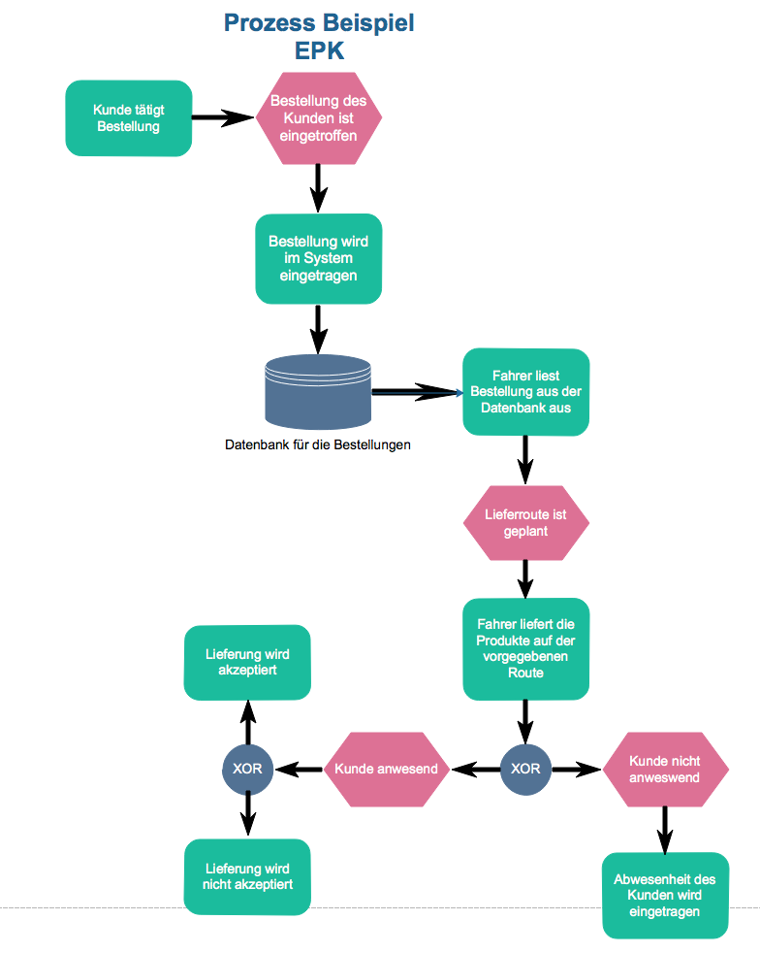

# Specific requirements

## Functional requirements

### Login Page

This is the first page the users get on, no matter what site of the program they want to open. The logisticians and the drivers can log in and they get on the personalized sites for the logisticians (all the same) and every driver (everyone has his own view because of their own tours).

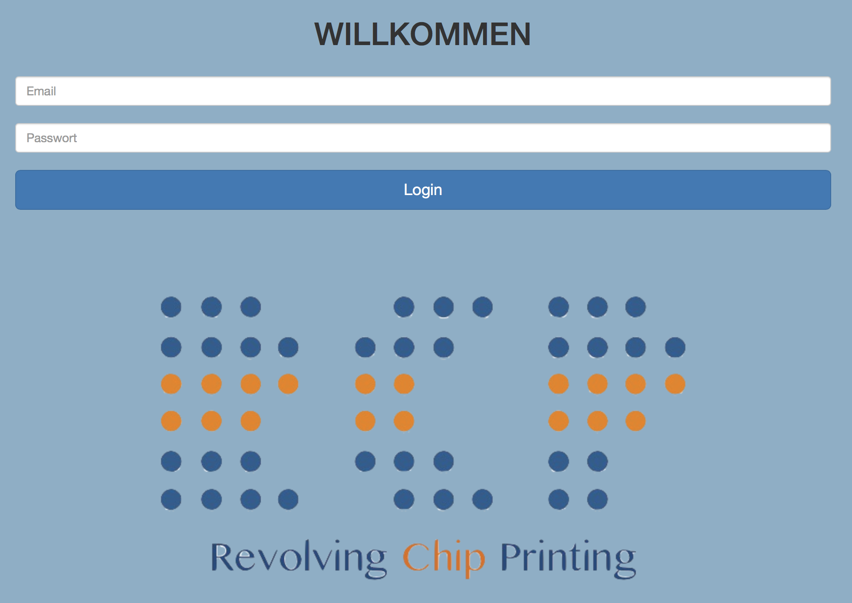

### User Class 1 – The Logistician

After the login, the logistician gets directly on the start page from the logisticians.

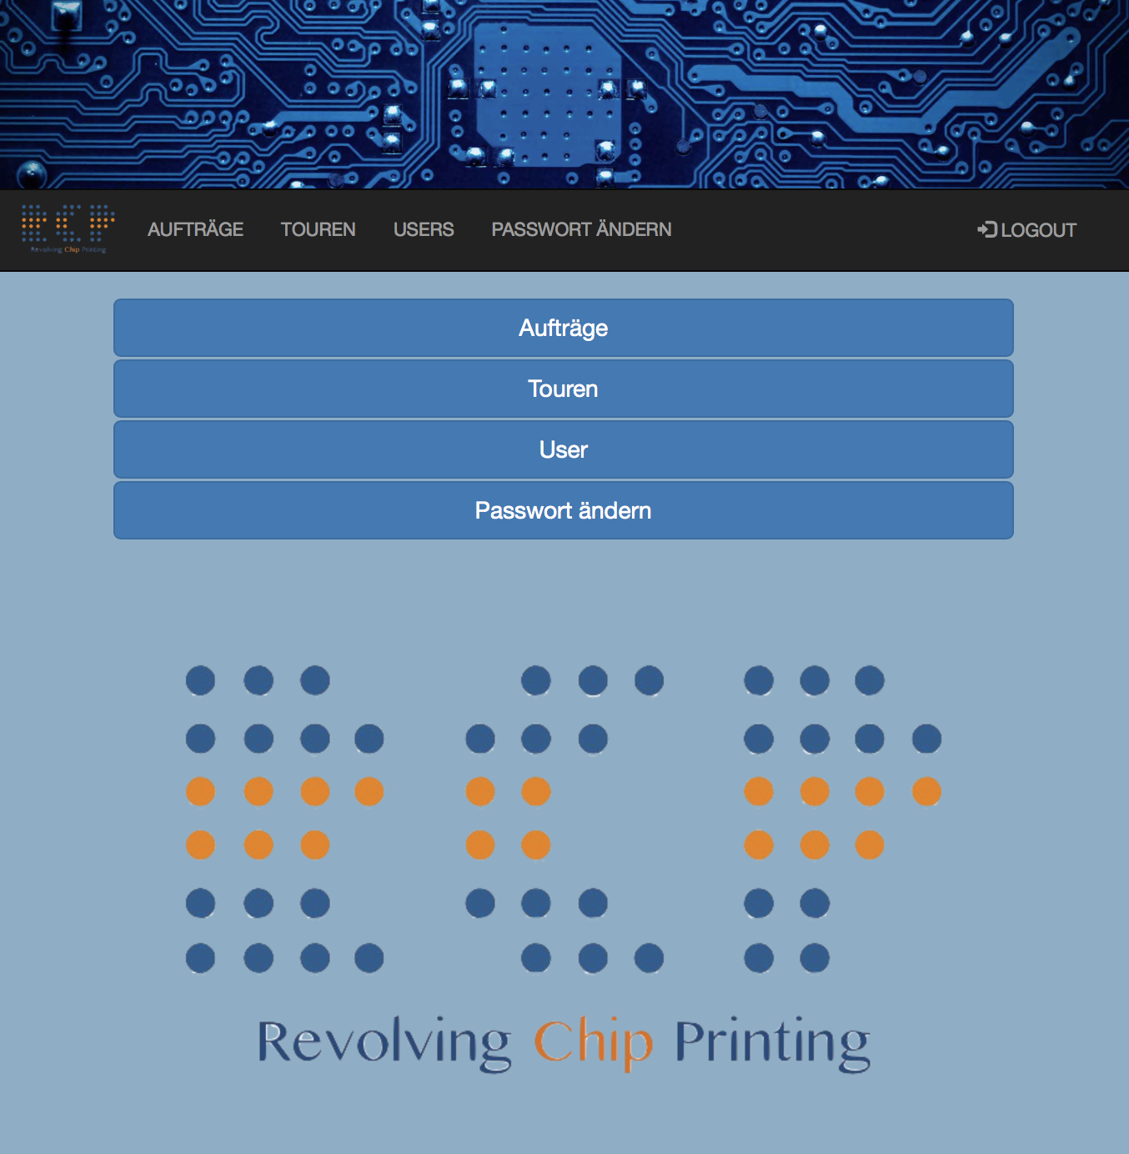Then the logistician is on the “logistician”-page. On this page, he has a first menu where he can choose his actions. He can choose between:

* Aufträge
* Touren
* User
* Passwort ändern
* Logout (on every page)

This different pages and stages of the program are shown on the next page. We also put screenshots in it to give an example of how the pages are looking and what is possible to do.

#### Aufträge

The logistician can look up all the orders that are in the system. He sees the ones that are not yet delivered and have to be edited, means that they have to be added to a driver for delivery. He also sees the ones that are delivered with success. The logistician can go back to the previous page or he can create a new order.

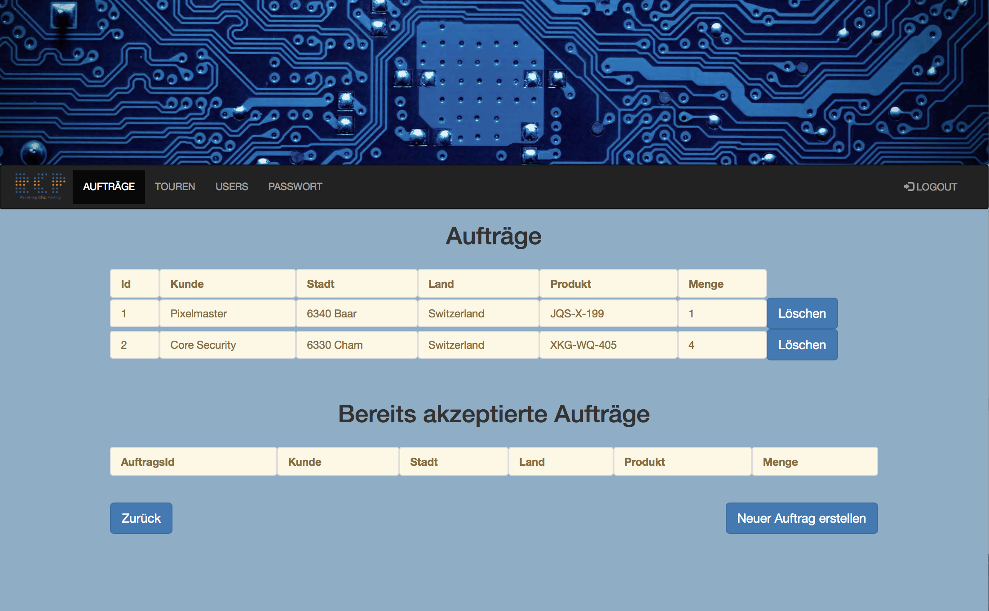

#### Touren

The logistician sees the tours that are in progress, he can also edit these tours. With a button, he can also look up the tours that are finished and he can design a new tour. The back button is also on the page.

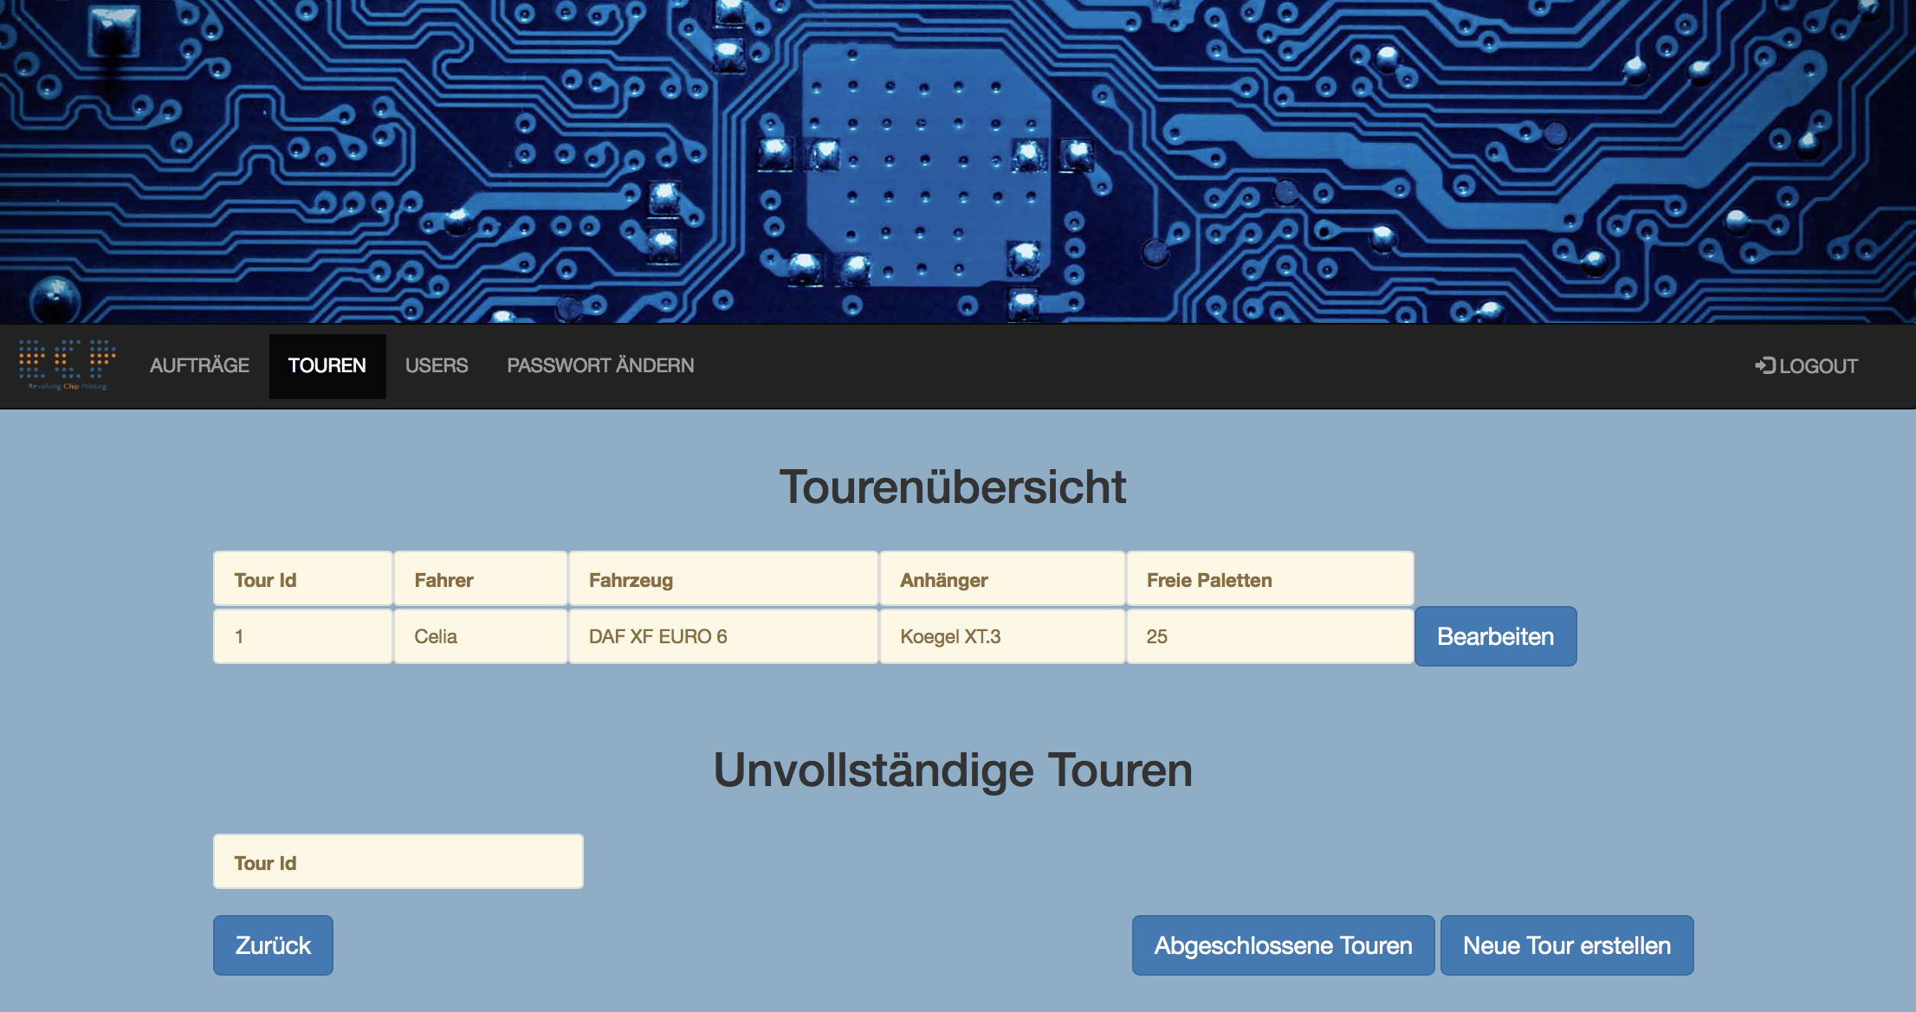

#### User

In user, the logistician can look up all the logisticians and the drivers that have an account in the system. He can also delete users.

#### Passwort ändern

Here the user can change his password.

#### Logout

This button logs the user out of the system. The login page is showed again.

### User Class 2 – The Driver

After the login, the driver gets directly on his own start page.

Then the driver page. On this page, he has a first menu where he can choose his actions. He can choose between:

* Touren anzeigen
* Passwort ändern
* Logout (on every page)

This different pages and stages of the program are shown on the next page. We also put screenshots in it to give an example of how the pages are looking and what is possible to do. The driver pages are designed for the mobile version, because they use it on the road.

#### Touren anzeigen

Here the different drivers see their own tours. For further informations of the tour he can push the button next to the tour. With the button on the left side he can go a page back.

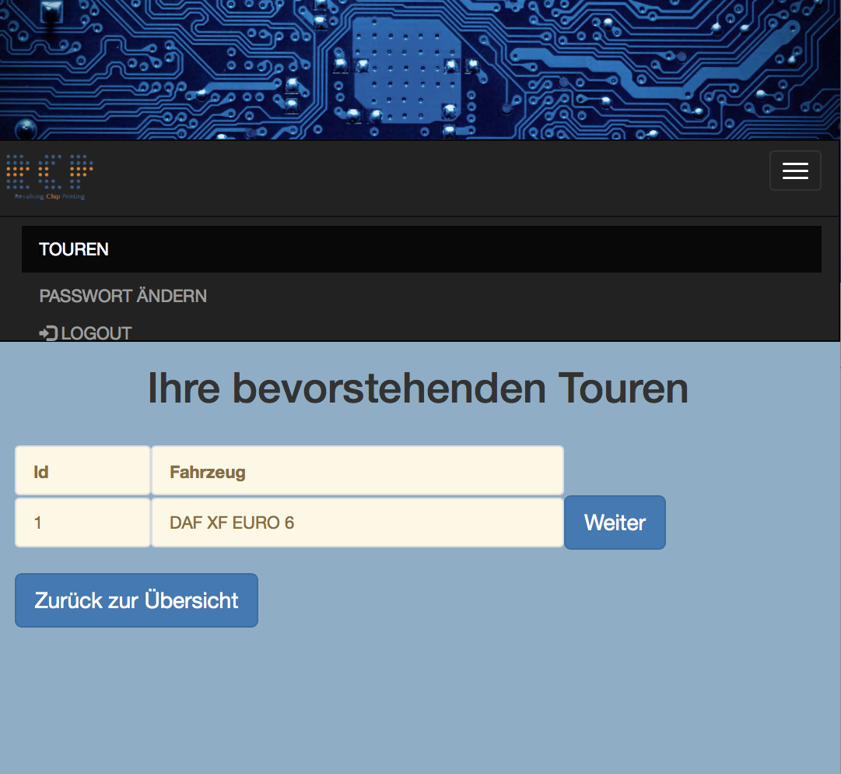

##### Tour

Here the driver can look up the route he has to take on a google maps map. He can choose between accept or reject of the orders, depends on what the customer says or if the customer is there or not.

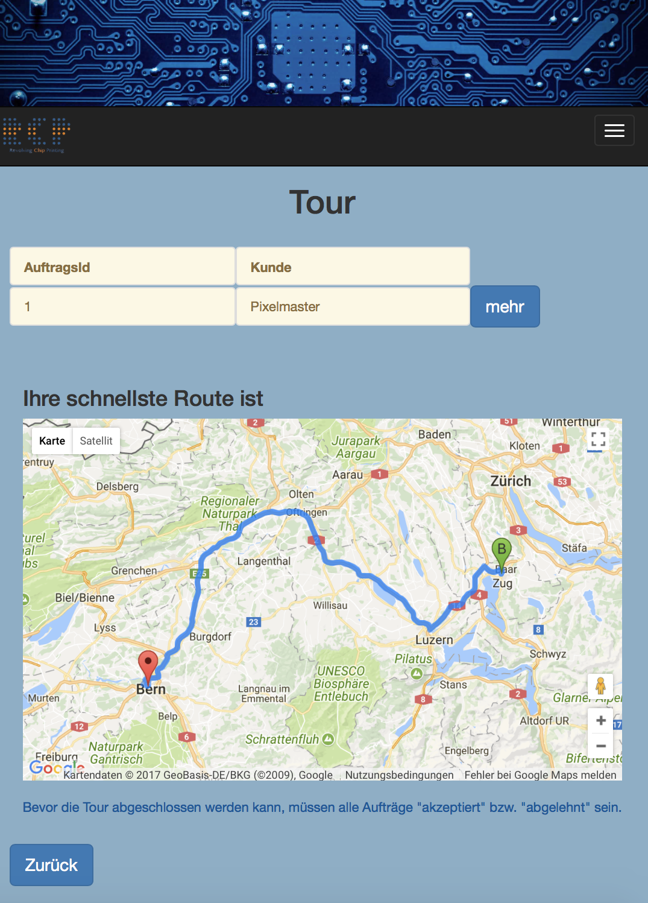

#### Logout

The driver can log out and gets back to the login page.

### Walk-through-diagram driver

### Walk-through-diagram logistician

## Non-functional requirements (external, performance, etc.)

### Desktop and mobile version

For our non-functional requirements, it is important that the Webpage is working properly in the normal desktop version for the logisticians and in the mobile version for the drivers. This saves both of them time because the design is adapted to each situation.

### Browsers

The aim was that the webpage is working on every common internet browser properly. We have tested our program on the following browsers:

* Internet Explorer
* Firefox
* Chrome
* Safari

On every one of them the webpage was displayed in the right way. The logo we put in was showed on every browser, the design was the same on every browser and there were no bugs or defects detected no matter what browser we used.

### Performance

Long waiting time is always to avoid. It is really important that a software works fast. In our case we never had waiting times that are inappropriate.

### Security

The users get first a predefined password. But they can change it when they are logged in every time. The password is encrypted so the safety is guaranteed.

### Usability

We designed the website in a way that should look nice. The design is basic and easy to understand. The system is easy to learn for new users. Everything is designed straight forward and there should not be not needed stuff on the different pages (no garbage). More on this in chapter design constraints.

### Documentation

With the use cases, we present in this SRS, the user has a help to go through the program and to learn things that they don’t get in the beginning. It’s a step to step help for a lot of different cases.

## Design constraints

### Colors

The aim was that the colors are pleasing to the eye. So, it shouldn’t be something too hard. Because of that we have chosen a light blue for the background and a darker blue for the buttons.

### Contrast

Over the time we achieved a good contrast from our light blue and dark blue. This helps the user to find everything fast because it is clearly visible. We first tried it with the light blue and orange, but with the time we saw that a darker blue would be nicer.

### Buttons

We tried to design the buttons big enough that every user can read it properly, also in the mobile version. The contrast of the font to the button is also there, that the font is better readable. The buttons are placed in the middle of the page or also in the edged, depends on what they do, but in our use cases, the users found that the design is really straight forward and it is clear what to do.

### Personalization

For the personalization of the webpage for the customer we included their logo big on the front page and on every other site, little in the upper left edge.

### Consistency

The design should be equal on every webpage. The colour of the background and the buttons should be consistent. The buttons should be at the same place.

### Toolbar

We integrated a toolbar to simplify the navigation in the program. The users see always which pages are available and they can access them easy and fast.

## Software System attributes

### Framework

Spring MVC is the application framework we used for our project. The aim of this framework is to simplify the development with Java/JavaEE and to promote good programming practices.

### Program structure

#### Java Packages

* Hello
  + Client
  + Configuration
  + Controllers
  + LoginRole
  + Product
  + ProductOrders
  + Repositories
  + Services
  + Tour
  + Trucks
  + Users

#### Resources

* Static
  + Images
  + ese.sql
* Templates (HTML)
  + acceptedOrRejected
  + addedClient
  + addedProduct
  + addedUser
  + changePassword
  + clientForm
  + deleteJob
  + deleteJobCheck
  + deleteTour
  + deleteTourCheck
  + deleteUser
  + deleteUserCheck
  + driver
  + driverProductOrder
  + driverTours
  + endTour
  + endTourCheck
  + foundClient
  + greeting
  + index
  + login
  + logistician
  + mapView
  + newTour
  + newTourProductOrders
  + newTourTrailer
  + newTourTruck
  + newUser
  + orderForm
  + registration
  + searchClient
  + selectClient
  + showJobs
  + showTours
  + showToursDriver
  + showUsers

The most important packages of our spring project are the following. The logic of the program is mostly in these packages integrated.

* Controllers
* Services
* Repositories

The controllers control the work between the classes and the html files. They work with @getMapping, @postMapping, @requestMapping. It controls which page is coming after a button is pushed. The lists of the database inputs are created with these controllers.

The services …

The Repositories …